Setting the PYTHONPATH environment variable

Python has a different path for importing modules than the Windows OS using for finding executables. Add that to the fact that Python buries its installation under about a half-dozen directories, and it can be hard to import Python modules from a file you have downloaded. The PIP installer makes sure that the path is correct for modules it installs, but you do not have that going for you when you just download a file. The PYTHONPATH environment variable is a good way to fix that.

# Find the full path to the directory where you put your files

I happened to put my files here. Your location will probably be different.  
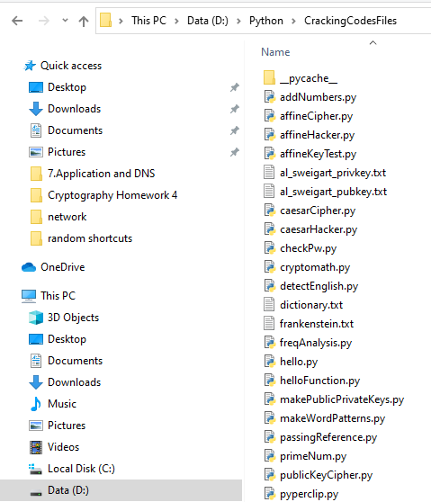

An easy way to get the full path is to click in the navigation bar at the top of file explorer, and then copy it.  
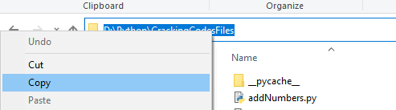

# Permanently create PYTHONPATH

Right-click This PC in File Explorer and select Properties.  
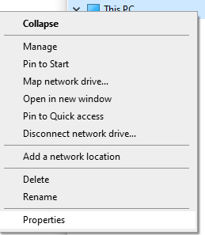

Select Advanced System Settings.  
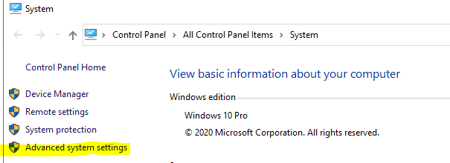

Select Environment Variables.

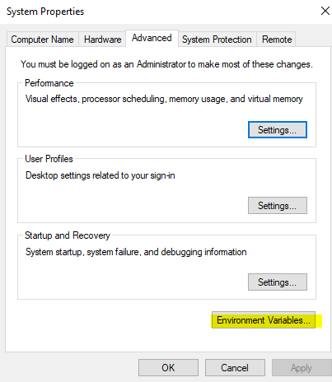

Select New. Enter PYTHONPATH in the Variable name, and either paste the path to your directory into Variable value, or use the Browse Directory button to find it. Click OK and you are done.  
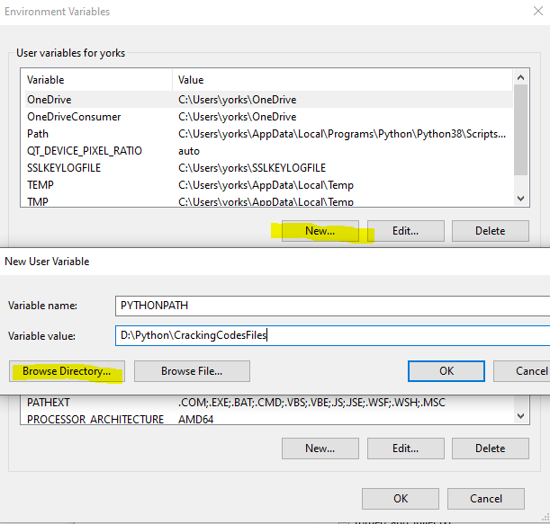

Now, Python will quietly import your module and stop giving nasty red error messages.  
